**ASSIGNMENT 3 – REDESIGN: Cloud 9 Walkers**

Link: <https://cloud9walkers.com/>

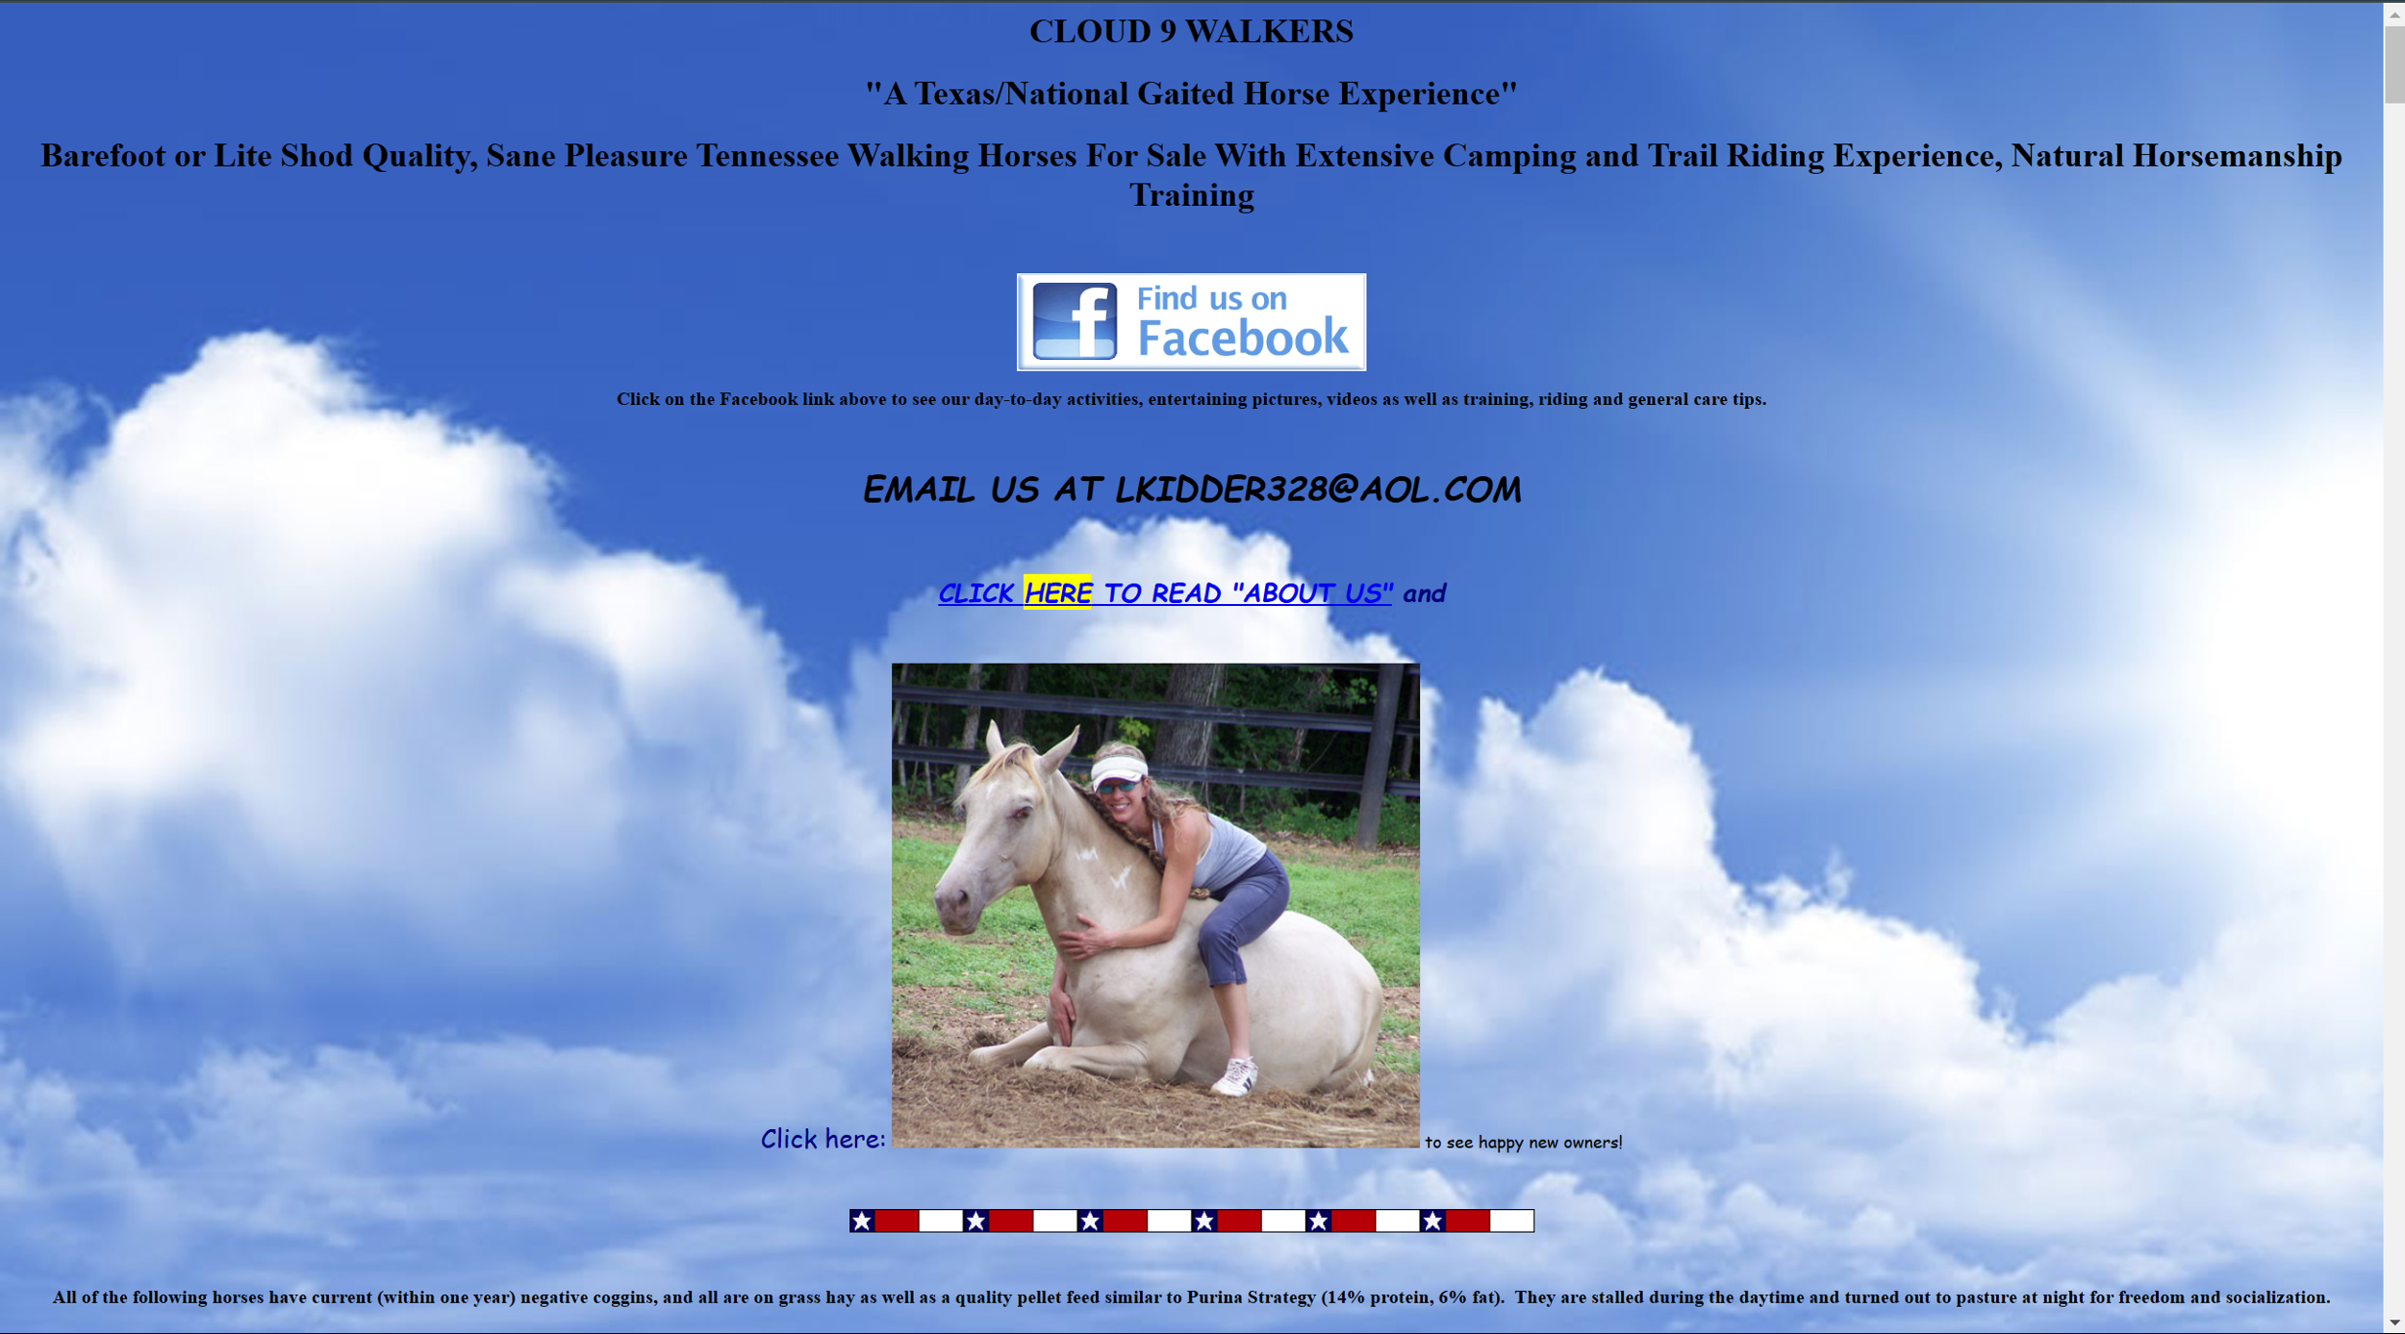

**Creative Rationale:** This website has some good ideas in terms of usability and highlighting links. However, it could use some work in terms of organization of the content. There is no clear structure or any sense of order on this website. All the elements were just placed underneath each other. To make it less chaotic, I put some of the elements in boxes. The links, mail and socials, which before only said “click me” and were randomly placed within the other text, I put in a tabline at the top for easier access and visibility. I thought it wasn’t necessary to point out facebook with text, because the icon should speak for itself.

Another thing I changed are the fonts and sizes, so they are cohesive and grab attention where necessary. In terms of the colours, the palette was not bad but could use a bit more variety. Right now, it’s too much blue and the text has not enough contrast to the background. I did like the use of the clouds, because they work with the name of the organization, but as the background for the whole page, it was a little distracting. Instead, I used a solid light grey color as the background. I still managed to use the clouds however by using them only as the background for the header as a fun but subtle accent motive.

Item #1

Description: Header & Subheader

Font: Header: Arial Black 30px; Subheader: Arial 24px

Color: Header: White; Subheader: Black;

Alignment: Center

Media: Cloud (Background)

Interactivity: N/A

Item #2

Description: Some text

Font: Arial 24px

Color: Black

Alignment: Center

Media: Horse Image

Interactivity: N/A

Item #3

Description: Mail

Font: Arial 24px

Color: Black

Alignment: Left

Media: N/A

Interactivity: N/A

Item #4

Description: Tabs + Facebook

Font: Arial 24px

Color: Black

Alignment: Right

Media: Facebook Icon

Interactivity: Links to pages